Contents

**Pythonanywhere** 1

**Google Cloud** 3

**AWS** 6

Starting instance 6

How to pick a good AWS server location? 7

Set up Alpaca Trade API. 13

How to connect AWS to GitHub? 13

Copying of file from local drive to the instance. 17

How to use environment variables? 20

How to read and download logs from an AWS instance? 20

Schedule scripts: 21

Closing your terminal without quitting your algo. 24

Start a new instance of screen 24

Terminate AWS Instance: 26

Tips for using Windows machine from AWS 26

Other advises 29

# **Pythonanywhere**

[Pylivetrader](https://github.com/alpacahq/pylivetrader) is the package that will allow Alpaca to understand Quantopian algos. Pylivetrader will only work with Python 3.6.

you’ll need to create a virtual environment with Python 3.6 and install pylivetrader

Open a bash on PythonAnywhere and type the following commands:

$ python3.6 -m venv venv  
$ source venv/bin/activate  
(venv)$ pip install pylivetrader

All the packages installed inside the virtual environment will only be accessible inside the same, here called ‘venv’. The Python version inside ‘venv’ will also be restricted to 3.6 (in this particular case); however, you can still use other python versions outside of the ‘venv’. In order to do so, simply type deactivate.

(venv)$ deactivate

You can jump right back into the virtual environment by typing:

$ source venv/bin/activate

Go to tasks, scroll all the way down to ‘Always-on tasks’, and type the following command:

source venv/bin/activate && pylivetrader run -f algo.py --backend-config config.yaml

# **Google Cloud**

Once you’ve signed up for a GCP account, head to the [GCP console](https://console.cloud.google.com/) and create a project.

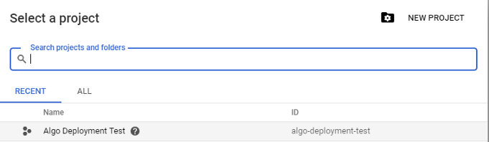

Hit “New Project”, and you can name it anything you like. I’ve named mine “Algo Deployment Test”.

Once you’ve created a project, go to the sidebar and navigate to Compute Engine > VM Instances. In this panel, you can see any instances you’ve created. That might be blank for now, but let’s go ahead and make one. Hit Create and fill out your configuration like this.

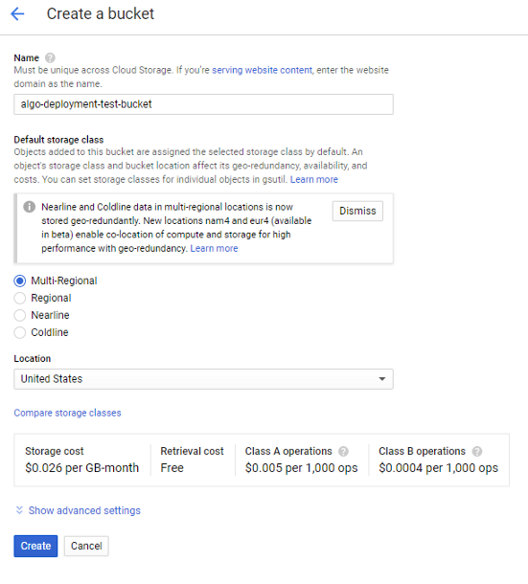

The only things you need to change are the name, which can be whatever you want, the “*Boot disk*” — we want **Ubuntu 18.04 LTS** - and the “*Machine Type*.” For machine type, choose the “*micro*” option there at the top to get the free tier. You’ll know that it’s free because the panel on the right will say that you have several hundred hours of f1-micro instance usage for free this month.

Hit Create at the bottom, and after a short bit of watching a circle spin, you’ll have a machine up and running, visible in the VM Instances panel. It’ll look something like this:

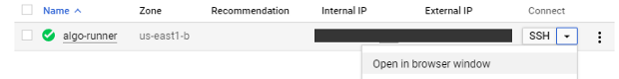

Your new compute instance where we’ll be running the script.

You can click Open in browser window to get a shell to the machine. Go ahead and do that now — we’ll need it in a minute. But before we type anything into the terminal, we need to get our script onto the machine. (You might know of some ways to do that through the terminal — if so, go for it! Or, you can follow along to do it through the GCP console interface.)

In the sidebar, scroll to Storage > Browser. On the Storage page, go ahead and hit Create Bucket. You’ll get a prompt like this:



We’re not too concerned about the storage cost, since we’ll be storing much less than 1 GB and only sharing it with our one instance. Once your bucket is created, it’s easy to put your files into it.

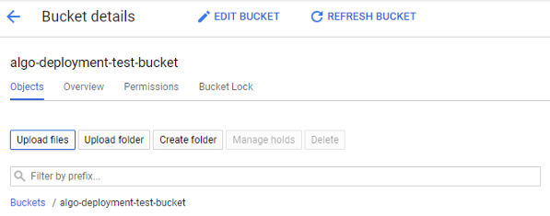

Hit “Upload files” to get files from your local machine into GCP.

Upload the requirements.txt and algo.py files and plugged your Alpaca API credentials into. All that’s left is to get the files onto our instance. In the browser terminal you’ve opened, you can type gsutil cp gs://<your-bucket-name>/* . to download your files onto the VM. The gsutil command pulls down files from the Google Storage system.

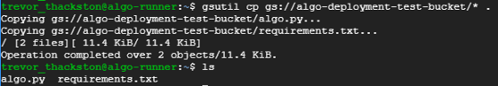

Now that the script is on the cloud instance, we just need to run it. Python is already installed, but to make requirement management easy, go ahead and download and install pip. In the VM terminal, do this:

sudo apt update

sudo apt install python3-pip

And then install the algorithm’s dependencies:

sudo pip3 install -r requirements.txt

type below into the VM’s terminal

python3 algo.py

# **AWS**

## Starting instance

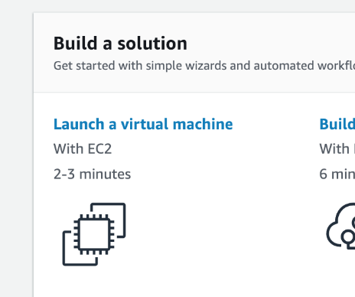When you sign in, “Launch a virtual machine” with EC2 on your front page. Click that. (Or, search “EC2” and click the “Launch Instance” button.)

Click the “**Amazon Linux 2 AMI**” free tier eligible option. Use the **t2.micro** free tier eligible and click “*Review and Launch*”.

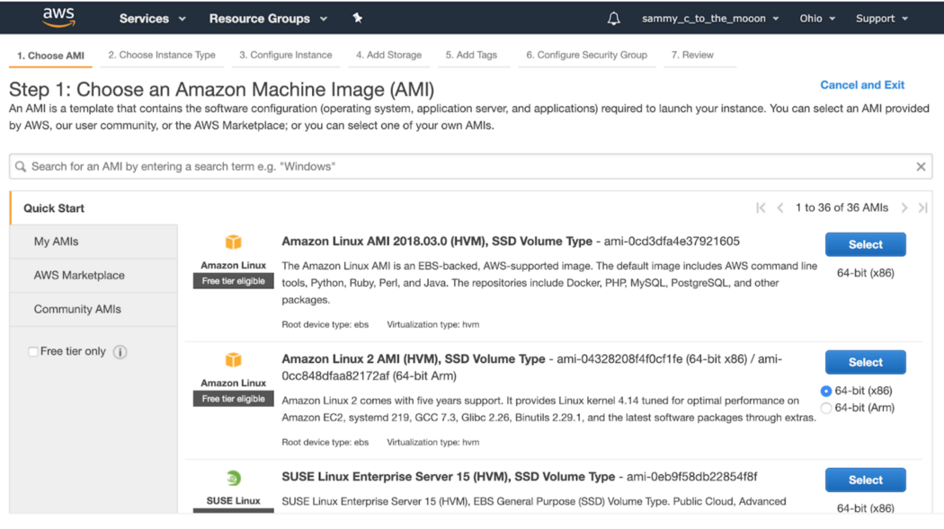

Another option:

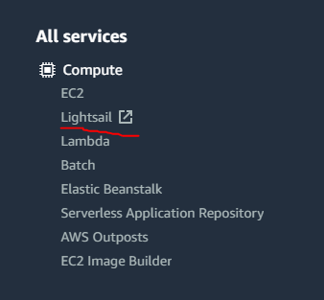go to “**Services**” which is located in the upper left corner, and select “**Lighsail**” which is found under the “Compute” category.

When there click on the orange “**Create instance**” button and let us get started with the server creation.

### How to pick a good AWS server location?

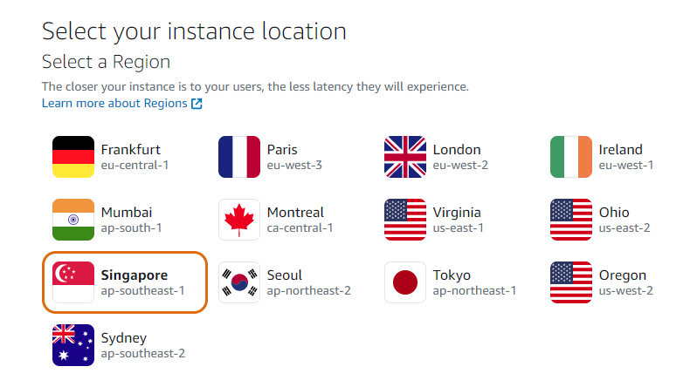going over to [this website](https://check-host.net/?lang=en) and inputting the API URL of our exchange. Now we do a Ping check by clicking the Ping button. The location with the lowest latencies is the best one for our exchange.

Change the Blueprint to be “**OS only**” as we are not creating a website or an app.

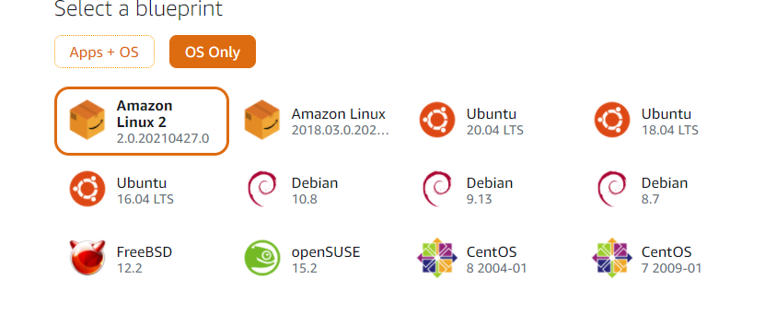

As Python and our requirements for the trading strategy don’t require much space and computing power, we can go with the cheapest instance. You can name your server too. 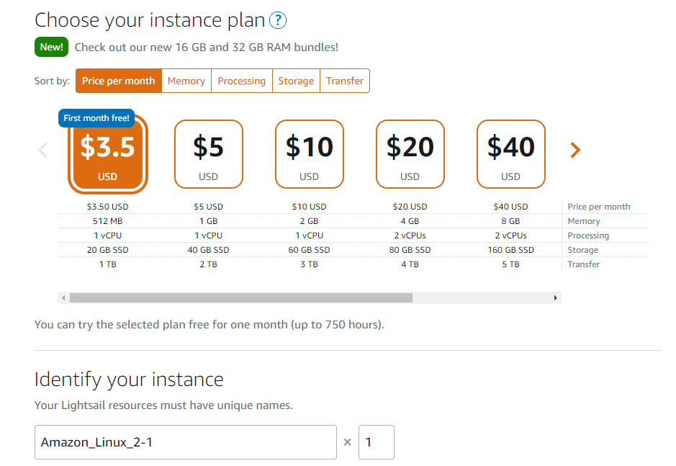

After that, at the bottom, you will find a create instance button that will complete the AWS server creation. After that, you will wait for a few seconds until your server comes online.

You need to change **security group** for the instance:

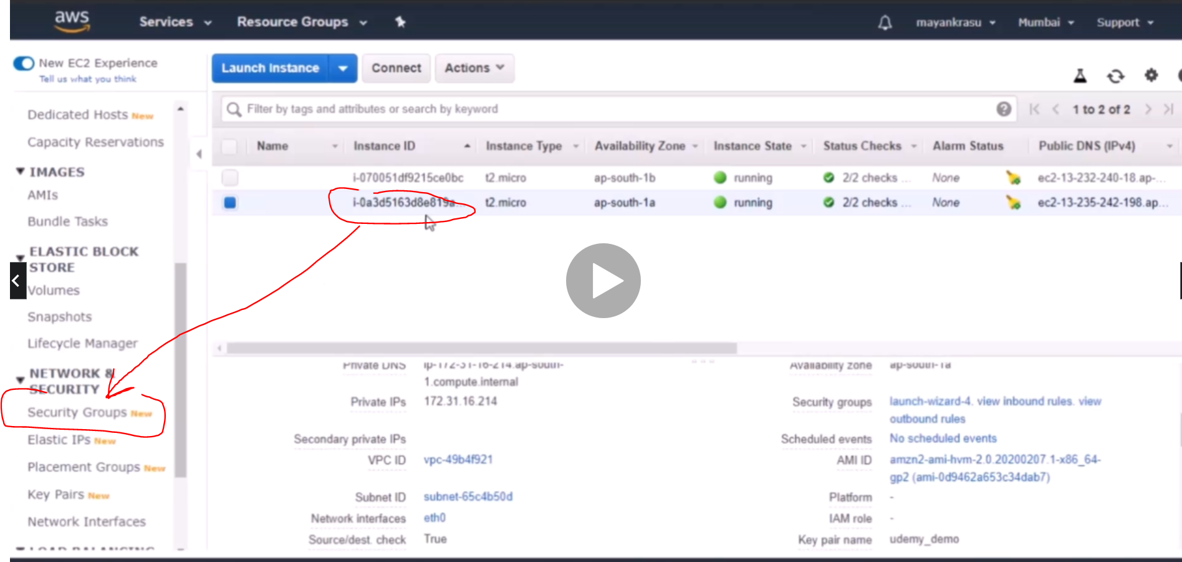

The inbound rules should be changed, that only your PC could connect to the AWS Instance

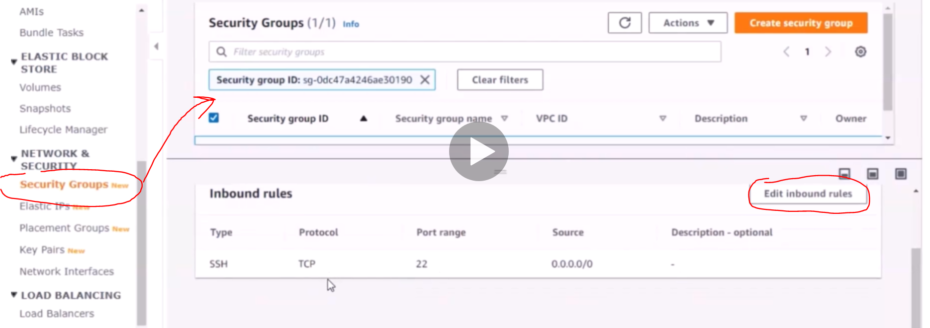

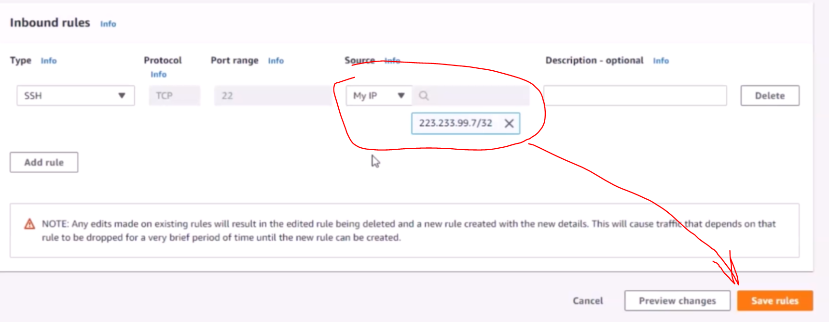

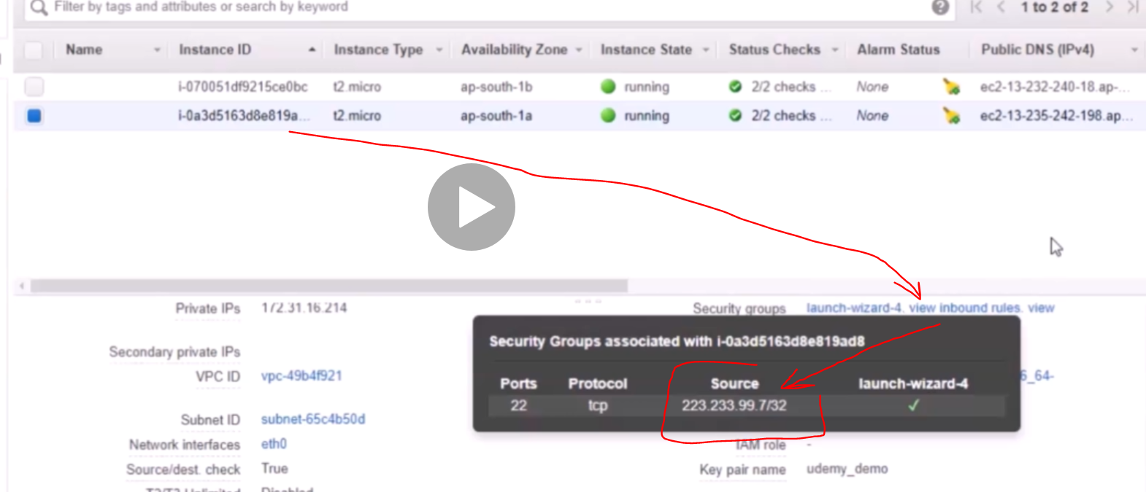

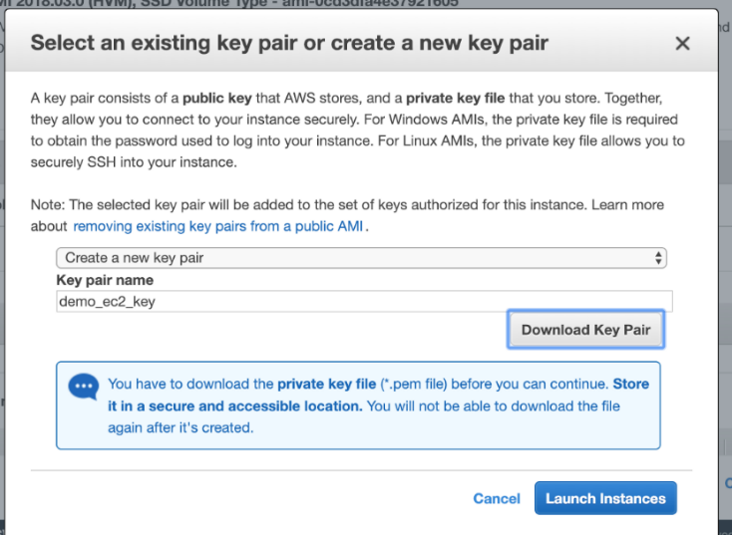You’ll get notified to set a security group if this is your first time create a new key pair and download the .pem file. **You’ll need the path to this file later.**

Click “Launch Instances”. Click the instance id link on the following page to go to your EC2 instances.

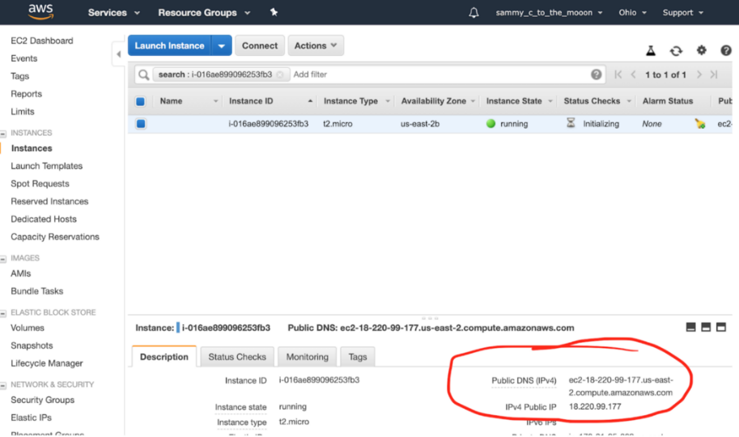

Your instance will take a bit to initialize, while it’s doing that, copy your public DNS.

Open a terminal window …

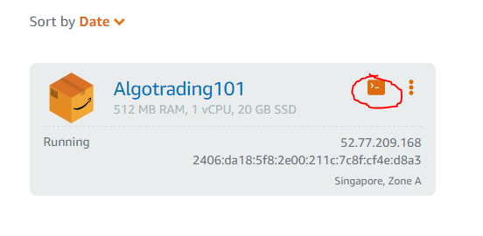

and type the following:

ssh -i [path to your key here] ec2-user@[your public DNS here]

My example:

ssh -i demo_ec2_key.pem ec2-user@ec2–18–220–99–177.us-east-2.compute.amazonaws.com

From Udemy:

Type:

ssh -i ~/udemy_demo.pem ec2-user@[your public DNS here]

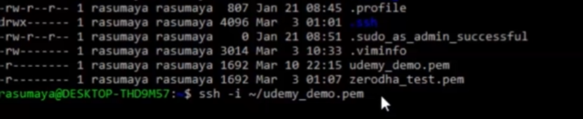

Copy Public DNS from AWS => Right click + paste DNS in the same line

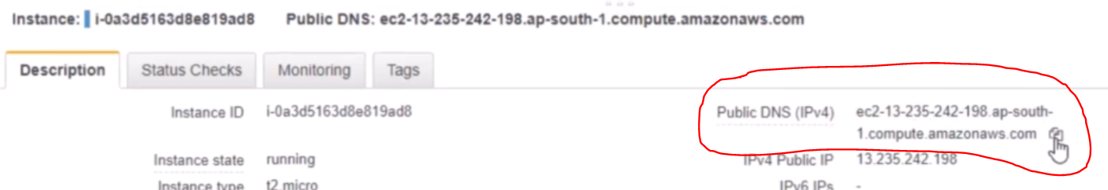



You should get smth like this:

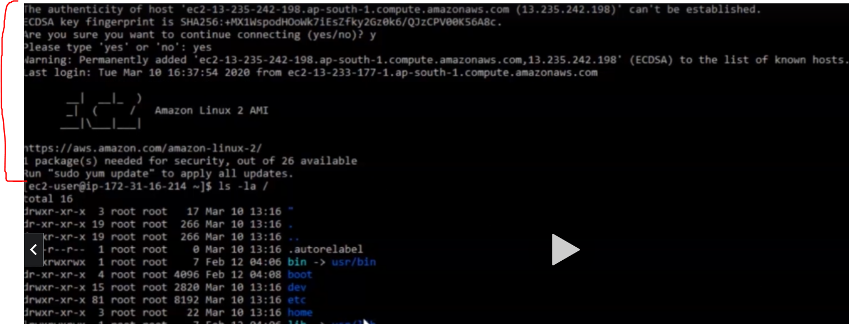

How to fix your key permissions

The first time you try to connect, you’ll probably get “bad permissions” as a result:

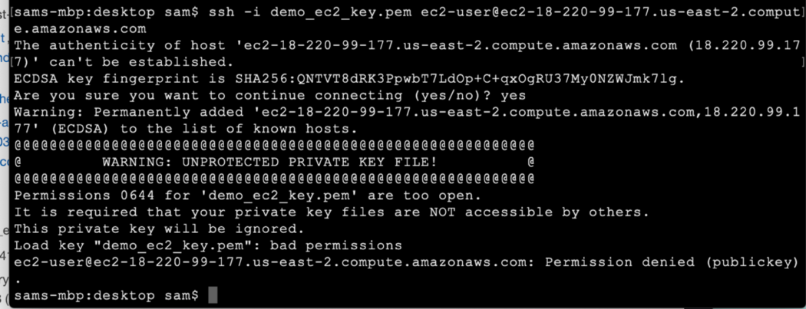

All you have to do fix this is run:

sudo chmod 600 [path to your key]

Now run the command again. This screen means you did everything correctly:

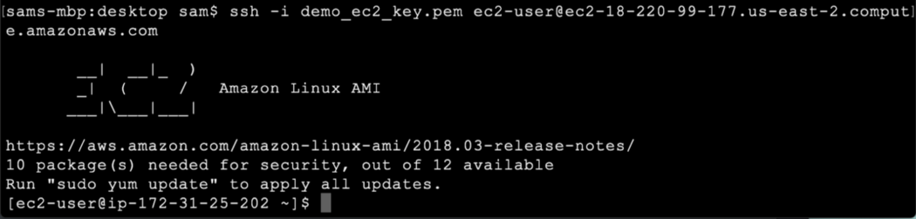

Windows doesn’t have Linux command prompt. I need to get [Windows Linux Subsystem](https://www.youtube.com/watch?v=Cvrqmq9A3tA)

We need to copy .pem file (the key file for AWS) from Windows folder to Linux folder: in the example the file is “udemy_demo.pem”

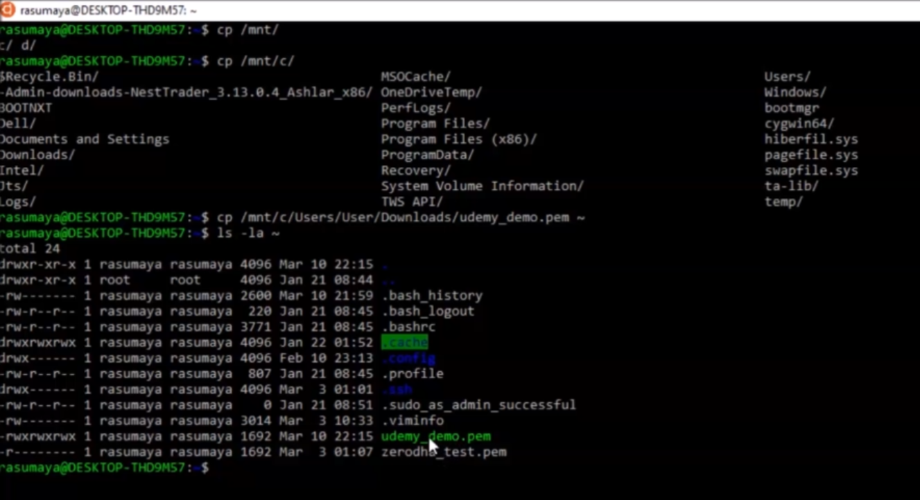

After copying it, we need to change the access rights to it, as aws will not allow pretty democratic access rights:

chmod go-rwx filename.pem

chmod u-wx filename.pem

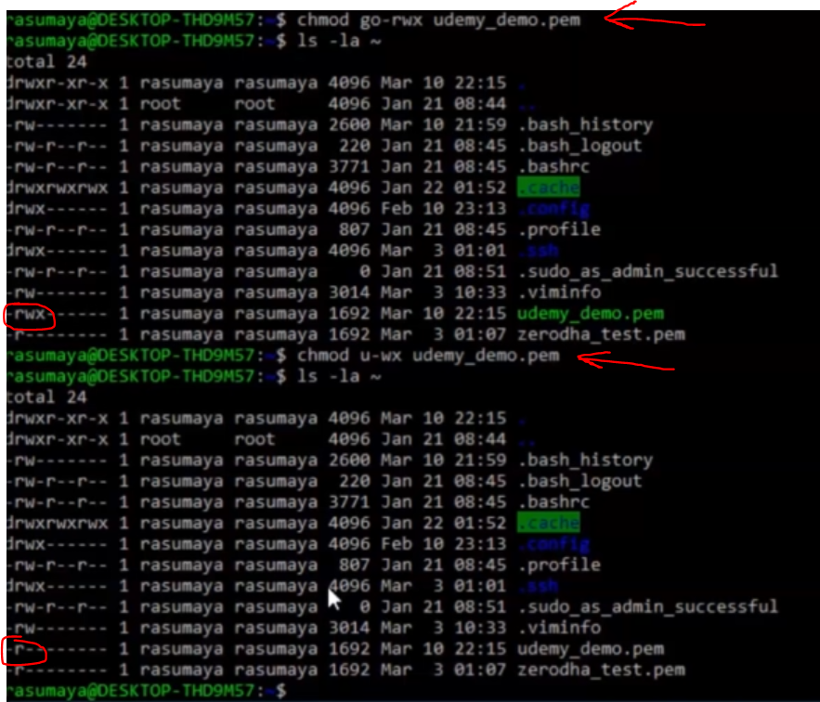

## Set up Alpaca Trade API.

Enter python -V or python3 –version to see what version of python you’re running. By default, I get 2.7. Run the following to install Python3.7:

sudo yum install python37

or

sudo yum install python3

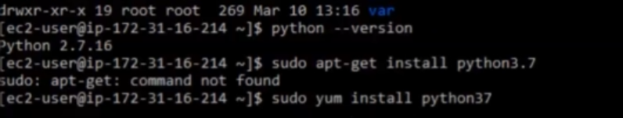

Documentation on installing python and pip in your ec2 instance is here: <https://docs.aws.amazon.com/elasticbeanstalk/latest/dg/eb-cli3-install-linux.html>

After installation of python:

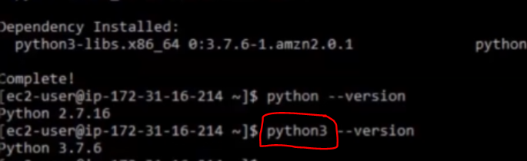

Install pip:

sudo yum install git

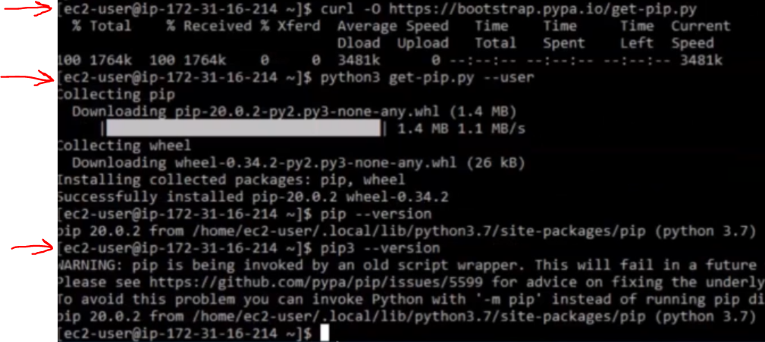

## How to connect AWS to GitHub?

In order to connect your AWS instance to GitHub, you will need to utilize the SSH (Secure Shell) method and Git.

This process can be viewed as being consisted of 3 main steps:

1. Create your special “keys” (like the API and secret key)
2. Upload the public key to GitHub
3. Use the keys when interacting with GitHub

Let’s create the keys. Write the following command in your AWS instance terminal

ssh-keygen

Then give it a name and the passphrase can be left blank. I’ll name it “algotrading”.

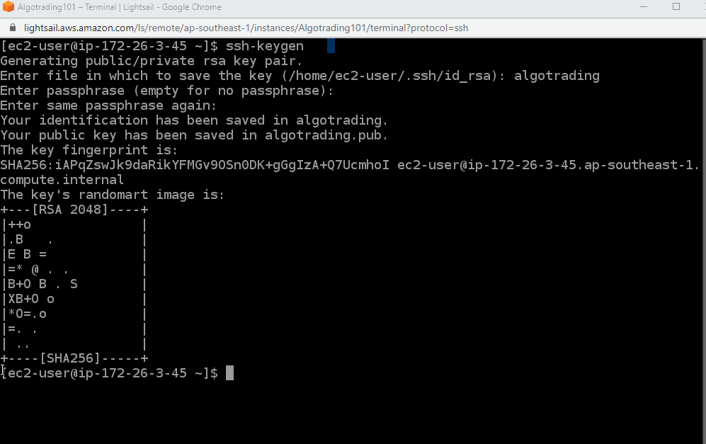

Now that your key is created, you can find it by writing the following commands. The first one is ls that will list all the folders that are in your AWS instance.

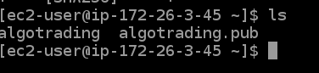

here you can see our two keys. The “algotrading” key can be viewed as our secret while the “algotrading.pub” key is the public aka API key. For us to import the key to our GitHub we need to read it first.

To do this write the following command and copy the output:

cat algotrading.pub

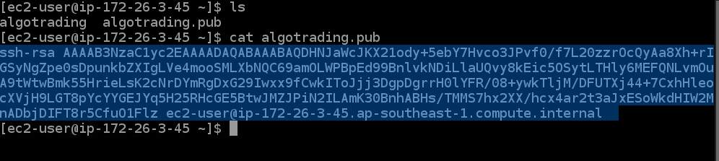

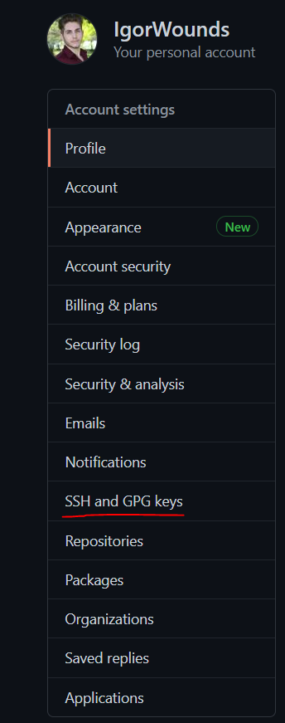Now it’s time to set this SSH key in our GitHub profile. Go over to your GitHub account -> Setting -> SSH and GPG keys.

When there, click on the green “New SSH key button”. Then give it a name and input the key. Then add the key and input your password when prompted. If you’ve done everything correctly the SSH should be ready.

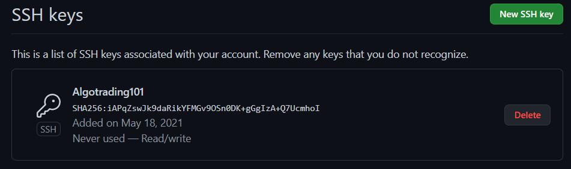

Now we will instantiate the private key.

eval "$(ssh-agent)"

ssh-add algotrading

That’s it, our AWS instance is ready. The two code snippets above need to be typed in your Terminal every time you run the AWS instance. Now, let’s test it out by pulling our trading strategy from a private repository.

Go over to your repository on GitHub, click on the green “Code” dropdown button, select SSH and copy the URL.

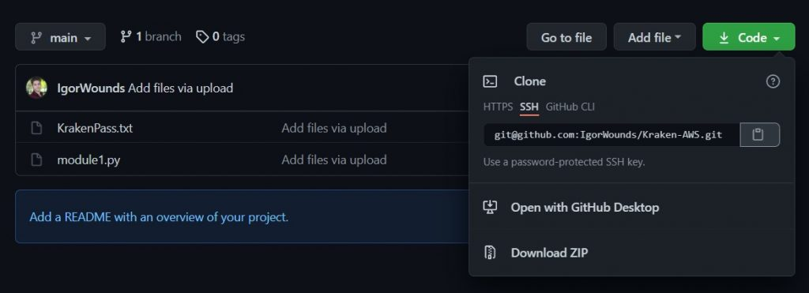

Now write the following function in your AWS instance:

git clone <SSH-URL-HERE>

yes

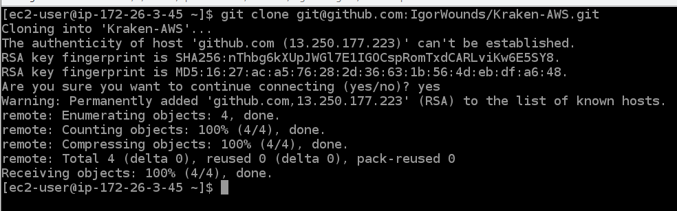

We successfully cloned out the GitHub repository to our AWS instance. In order to confirm this write ls

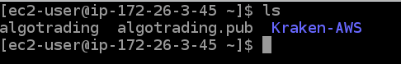

If you have many dependencies (Libraries) you can utilize the pipreqs library that will export all the libraries your script is using into a .txt file that can be read by our AWS instance.

You can use this library in two ways, the first way would be to install the pipreqs library on your local machine and generate a .txt file there, upload it to GitHub, and then pull it to your AWS instance.

The second way is to install the library in your AWS instance and generate the .txt file there. I’m more of a fan of the second way as it is more efficient, so let’s go with it.

Type the following command to install the pipreqs library:

sudo pip3 install pipreqs

Then list all of the documents that are located in our AWS instance with ls and hone into the file you want the dependencies to be generated from. In our case, it is the Kraken-AWS file and we write this:

cd Kraken-AWS

Then create the requirements file:

pipreqs

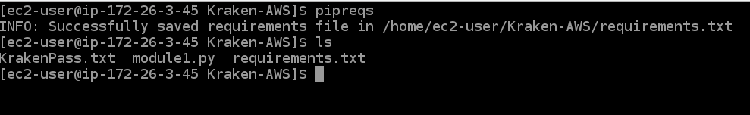

As you can see we have our requirements.txt file inside of the Kraken-AWS folder. Now that we have it you can install the requirements with the following command:

sudo pip3 install -r requirements.txt

That’s it! Notice: To go back in your file hierarchy just type the following line that will take you a step back

cd ..

Now you need to install all the libraries to run algo. E.g. like below:

pip3 install --user alpaca-trade-api

Now your EC2 instance should be good to go! Keep this window up for later.

## Copying of file from local drive to the instance.

Open a new Ubuntu terminal window, and run the following:

scp -i [path to your key] [path to your algo] ec2-user@[your public DNS]:/~

My example with apca_5min_ema.py as a strategy file name:

scp -i demo_ec2_key.pem apca_5min_ema.py ec2-user@ec2–18–220–99–177.us-east-2.compute.amazonaws.com:~/

Go over to your original EC2 window, and run ls to check if the upload worked.

You should see your algorithm listed in the directory. Test it by running python3 apca_5min_ema.py.

You could copy the entire folder:

This is the EC2 instance:

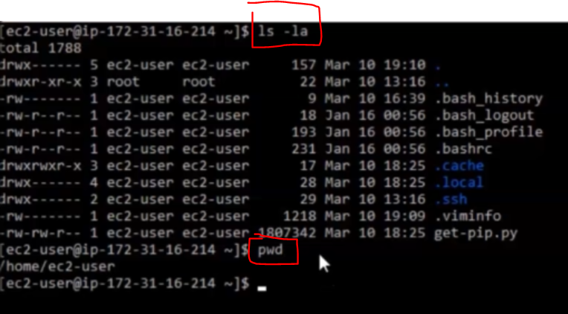

Type:

scp -i <identification key path> -r <path to folder in your local pc> <instance_username@instance_ip>:<instance path where the folder will be saved>

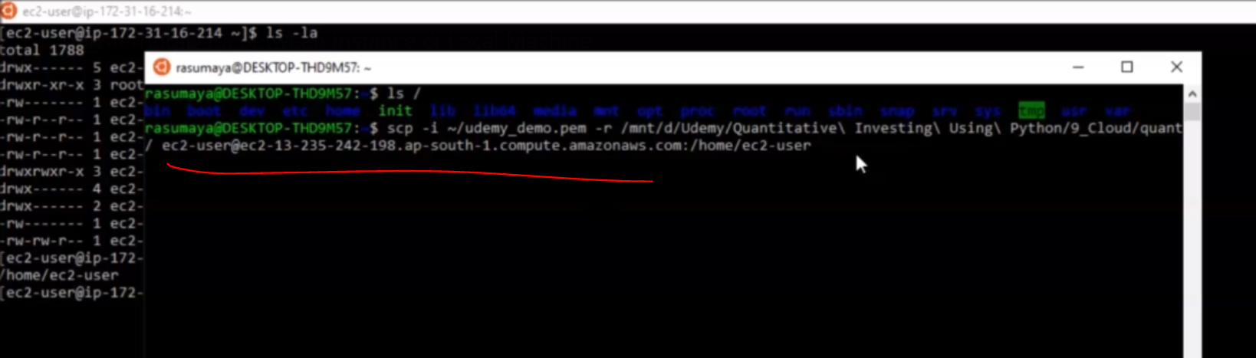

New folder has been created:

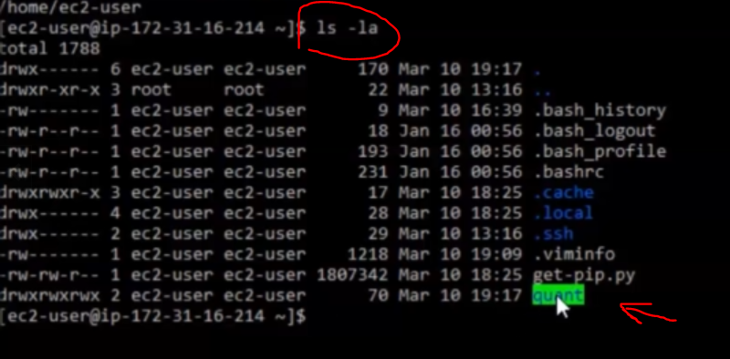

Let’s check the folder:

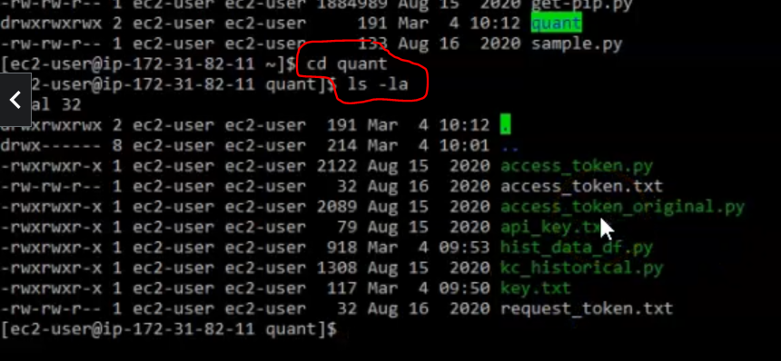

We could run the file:

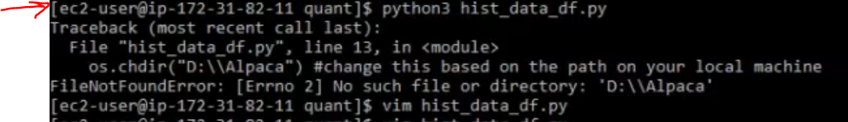

… but there was a problem as the script contained “D:\\Alpaca” path, but there is no such path on EC2 instance. The guy edited the script with vim, but it is nicer to edit it before transferring to AWS

## How to use environment variables?

In order to use the environment variables with in you AWS instance you will need to use the export command and state the values for those variables.

Let’s do it with our AWS instance and see how the code runs. We’ll start with a fresh AWS instance connection and go through all the steps.

eval "$(ssh-agent)"

ssh-add algotrading

cd Kraken-AWS

Now we can set up the environmental variables by typing export followed by the variable name and the value that we will assign it. In our case we have three environmental variables which are the following:

track_ticker = os.environ.get('ticker_to_track')

trade_ticker = os.environ.get('ticker_to_trade')

logname = os.environ.get('my_log_name') # Name of the saved log file

No we will assign them and launch our script:

export ticker_to_track='BTCUSD'

export ticker_to_trade='ETHUSD'

export my_log_name='log_kraken'

We have basically stated that we want to track BTC and trade ETH (as per our trade logic) and store the longs in a file named ‘log_kraken’. Now we can run the strategy with the following command:

python3 module1.py

And our script is operational and running. You can confirm this by the logs that are appearing. But how do we export these logs so that they can be read later on?

## How to read and download logs from an AWS instance?

To read the logs from your AWS instance you can use the cat command followed by the name of your log file. To download the logs, you can push them to your GitHub repo from the AWS server instance.

Let’s check out the logs that are situated in the log_kraken file and read them with the following command:

cat log_kraken

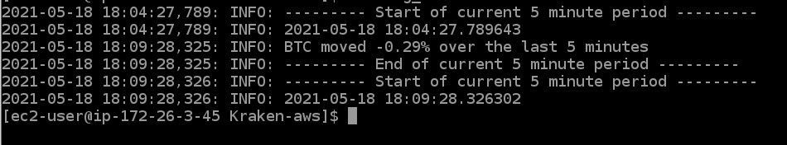

Now, we will push this log file to our GitHub. For this be sure to be in the right repo. Then type the following command that will prepare the changes to be added to our GitHub repo:

git add .

After that let’s confirm the changes by commiting them:

git commit -m "Add Log files"

Now that the log files are ready we can push them to our GitHub with this command:

git push <SSH-URL-HERE>

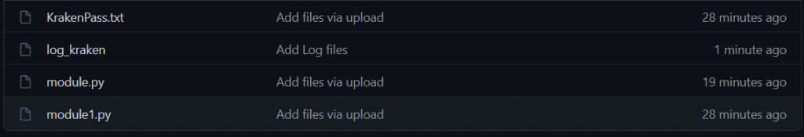

As you can see, the log files has been added to our GitHub repo.

# Schedule scripts:

Create an auto_script with vim.

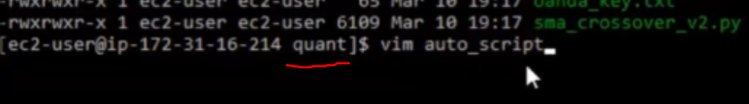

1. go to your folder with scripts
2. vim auto_script
3. vim opens
4. press [insert]
5. type:

* cd /home/ec2-user/quant
* python3 alpaca_script.py

1. press [esc]
2. type wq! *# write and quit*

This file could also pre-create on windows as a .txt file. But then you should rename it:

mv auto_script.txt auto_script

If the file is created in vim, it is created as non-executable (no “x” in permissions) and we need to change the permissions:

chmod u+x auto_script

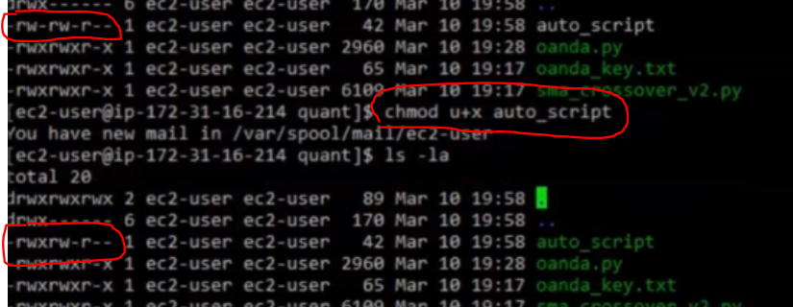

This file will be run with **crontab** (Basic introduction of crontab - <https://www.thegeekstuff.com/2009/06/15-practical-crontab-examples/> )

At first check if crontab is already running: service crond status

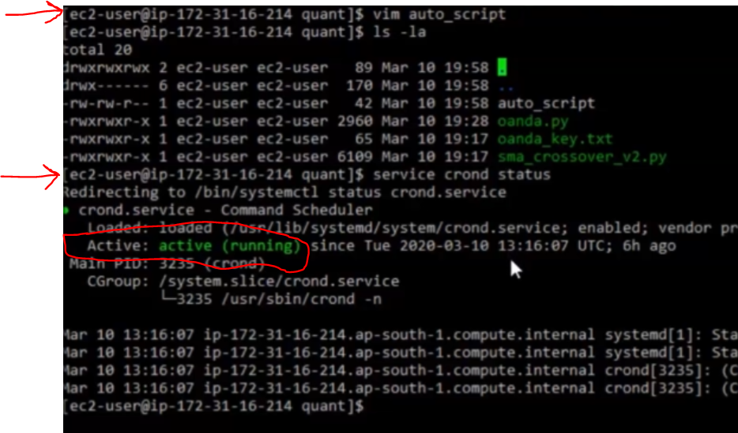

If it is not running, then start it: start crond service

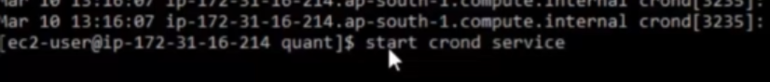

Check system time:

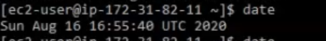

1. crontab -e
2. smth like vim opens
3. press [insert]
4. 00 09 * * 1-5 /home/ec2-user/quant/auto_script *# run you file every day at 9 am (monday to friday)*
5. press [esc]
6. type wq! *# write and quit*

If you schedule a script via crontab, you could also type screen commands there and add -dm to run it in detached mode (in the backgound)

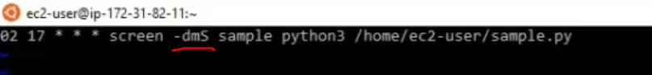

Checking how the jobs are running

E.g. a process running in the terminal. Open new terminal and …

ps aux *# smth like task manager in linux*

kill [process id]

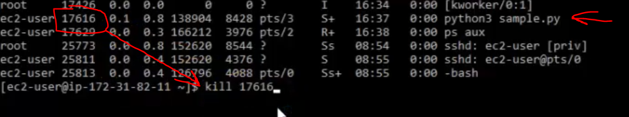

Or: ps aux | grep python *# to find all currently running process with “python” in the name*

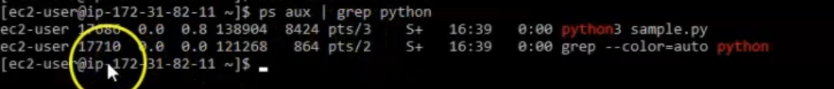

On the 1st terminal you will see:

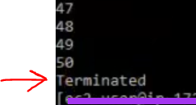

# Closing your terminal without quitting your algo.

## Start a new instance of screen

In order to keep our algo running without quitting when we disconnect, we can use a handy Linux command, screen. Go ahead and run it.

This will pop up a new, blank terminal. It’s actually another window of your terminal. Now run python3 apca_algo.py.

Or you could open new terminal and type screen -S sample python3 sample.py

Here “sample” is the name of the screen.



Hit **CTRL + A + D** to detach the screen and return to your normal terminal.

Now you can type screen -ls to see your process is still running.

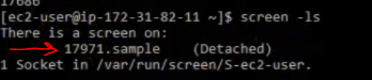

IF you type screen -r 17971 you will come back to your running script

Typing tail apca_log.log confirms this as well, seeing the results in our log file.

Hit **CTRL + D** to logout of EC2 altogether.

If you schedule a script via crontab, you could also type screen commands there and add -dm to run it in detached mode (in the backgound)



Log into your Alpaca account, and confirm your orders are being placed.

Reconnecting to your screen

To get back to your algo, log into EC2 with SSH.

Run screen -ls to see what screens are running. You should see something like:

There is a screen on:  
 3634.pts-0.ip-172–31–34–247 (Detached)  
1 Socket in /var/run/screen/S-ec2-user.

That long screen id is what you’ll type in next to reconnect:

screen -r 3634.pts-0.ip-172–31–34–247

Alternatively, if you just want to quit the screen you can use ps aux | grep apca_5min_algo.py to see the process ID:

ec2-user 3658 0.1 6.4 427400 65388 pts/1 S+ 22:14 0:00 python3 **apca_5min_ema.py**ec2-user 3726 0.0 0.1 119468 1040 pts/0 S+ 22:20 0:00 grep — color=auto **apca_5min_ema.py**

Then, you can use screen -XS [process id] quit to quit the screen immediately. My example:

screen -SX 3658 quit

Finally, confirm if you’ve quit your algo with screen -ls .

There you have it! This should give you a good starting point for spinning up new EC2 instances, navigating AWS, and managing your algorithms.

You can also open multiple screens by using the screen creation command and run a custom script in each of them. Your screens can even have the same name.

If you want to see all the screen that you have you can type this:

screen -ls

If you want to delete your screens you can either delete them one by one or all at once. Here are the commands where the first one does the former and the second one does the latter:

# Type this while in the screen

exit

# To delete all screens

pkill screen

# Terminate AWS Instance:

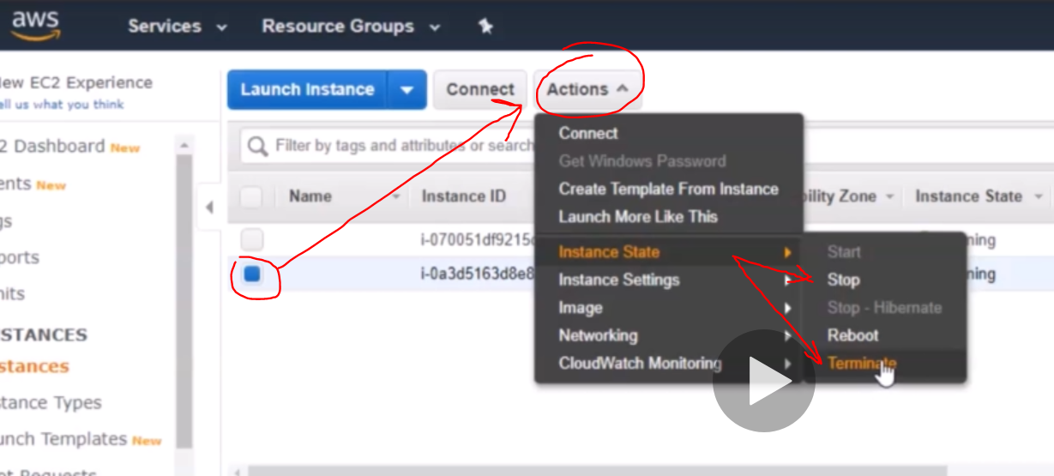

# Tips for using Windows machine from AWS

How to connect to local resources:

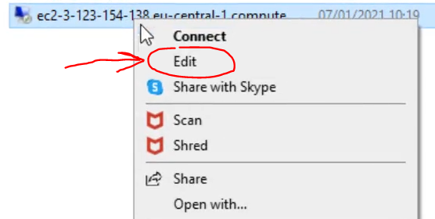 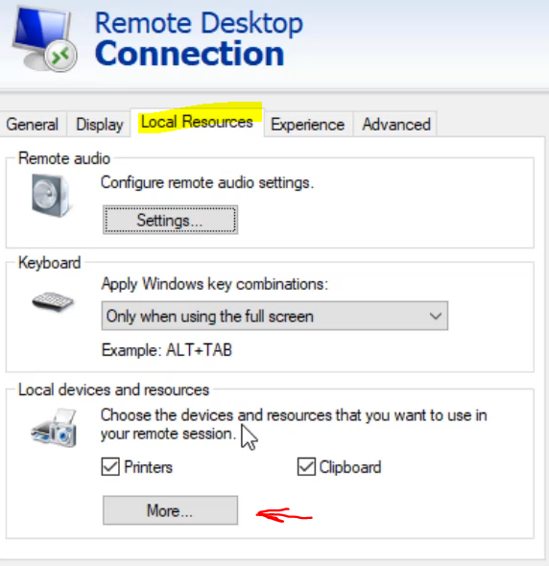 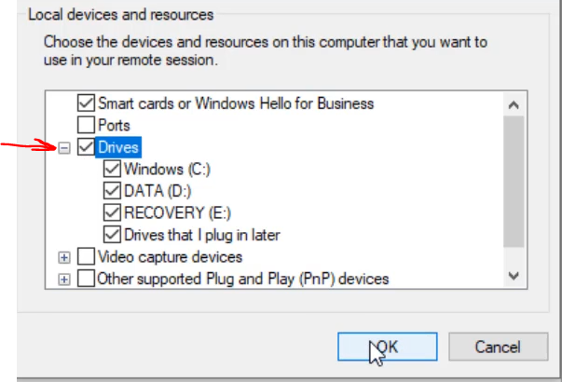

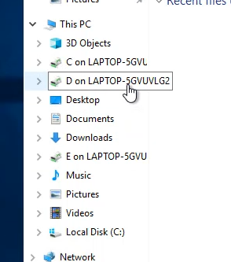

How to edit filepath of python file:

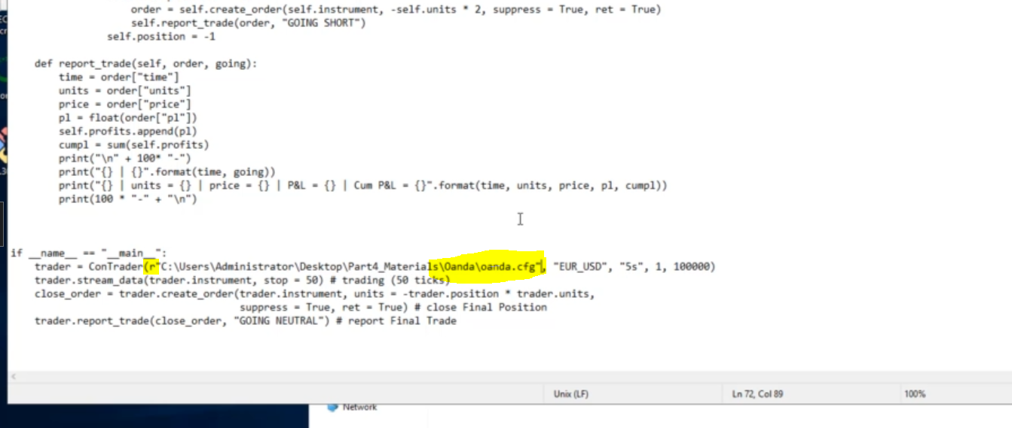

Copy path of the file by right click => properties:

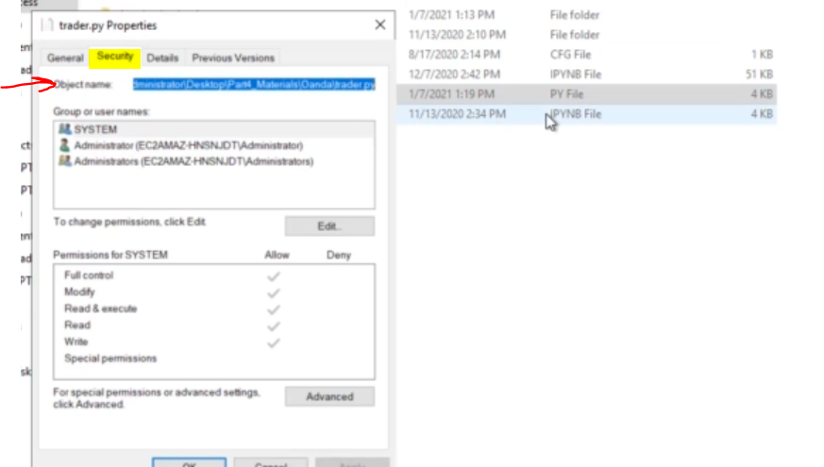

Run Anaconda Prompt and type “python“ and paste the file path:

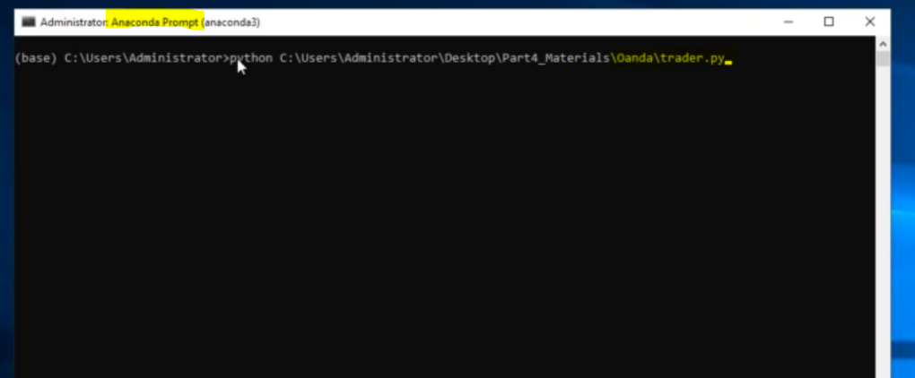

How to run python script in windows command prompt:

Copy filepath to the Anaconda batch file “activate.bat” => open Windows Command Prompt => paste the filepath => press Enter = we switch to Anaconda prompt. Now we could copy peth to the python script and type “python “ + paste the path and press enter to run the python script

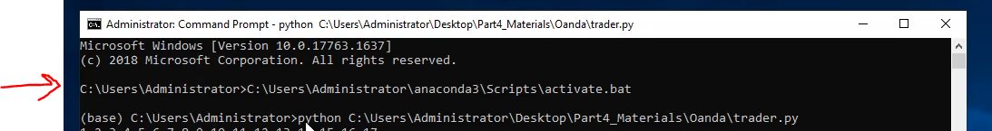

So just copy these 2 commands to the Notepad file. But add “call “ before the command to run the anaconda batch file. “cmd/k” means “*do not close command prompt in the end”*.

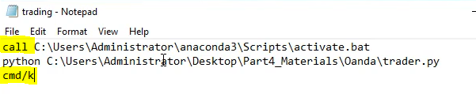

Save this file as .bat and select “All Files”

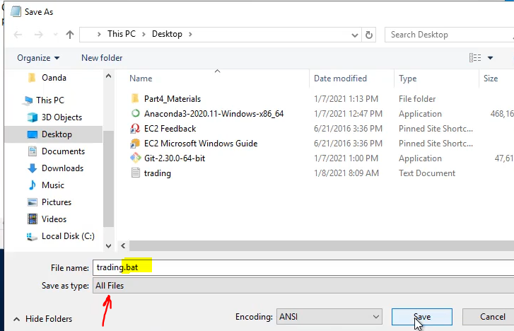

So you could just double-click the created batch file and the python script will run. Or make a scheduler:

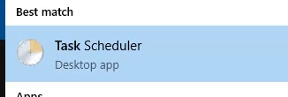

# Other advises

Q: *Does anyone have experience using "Google Cloud Run" for deploying an alpaca trade api program in Python? My problem is that the websocket is returning an error:Exception from websocket connection: There is no current event loop in thread 'ThreadPoolExecutor-0_0'. The rest API calls are working fine. And the websockets are working when I run the program locally.*

If you are using the standard Alpaca SDKs, websockets may need some tweaking to run on ‘cloud run’. The problem is ‘cloud run’ requires an app to be stateless because it can start and stop and be run on a different instance at any time. Websockets however are stateful and require a bit of extra consideration. Take a look at [this explanation](https://cloud.google.com/run/docs/triggering/websockets).